
®

Micro Family
TM

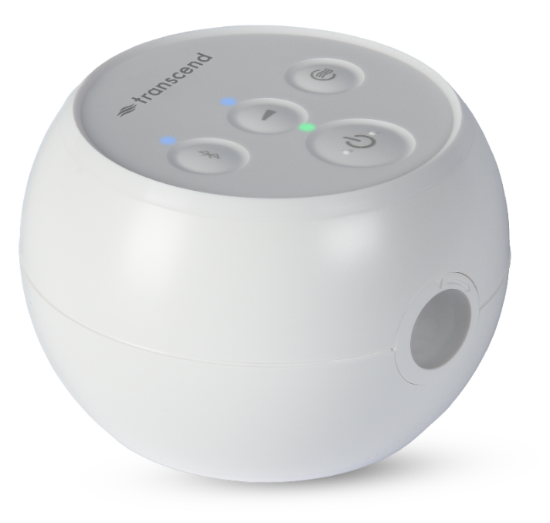

Desktop Software User Guide

Table of Contents
Transcend Software User Guide 3
Configuration 5
Compliance Manager 7
General Functions 8
Contact Transcend Inc. 12

Transcend Software User Guide
Your Transcend Micro device comes with easy-to-use software to help adjust settings, observe, print and send reports, and store all your data so you can access it any time.
Three Simple Steps and you’re ready to use your software.
STEP 1
- Start by downloading the device software onto your computer. Once you download the software, it will automatically update as changes and improvements are made to the software.
  - Software download link: mytranscend.com/software
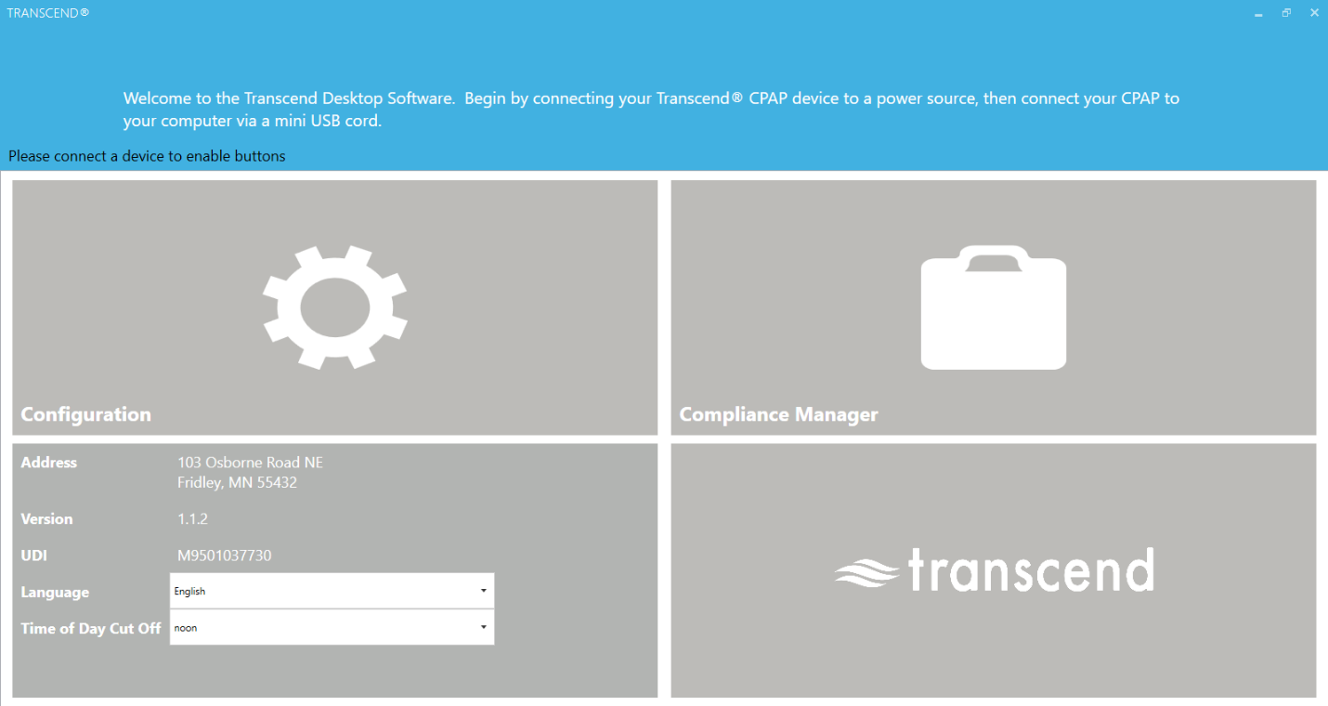When you open the software, the home screen will appear.
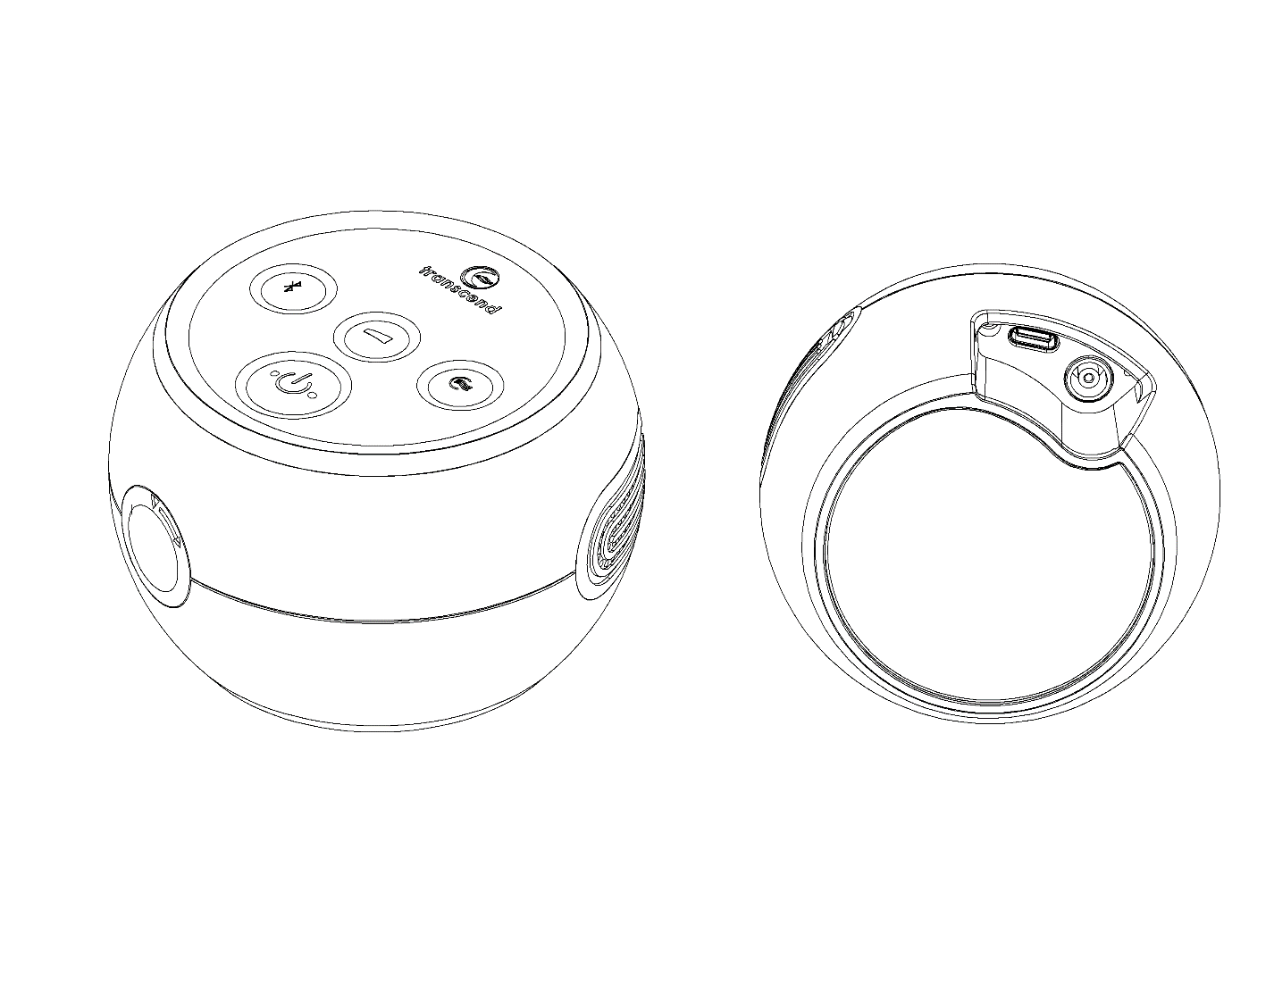
USBC data port
Power port
STEP 2
Connect your Transcend Micro device
to a power source, then connect it to
your computer using a USBC data cord.
Connect only to certified IEC 60950 or
IEC 60601 computers.

STEP 3
- Select your preferred language by choosing from the dropdown menu.
- Select your Time of Day Cut Off from the dropdown menu. This will be used to group sleep sessions into 24-hour days. Choose a time when you are least likely to be sleeping.
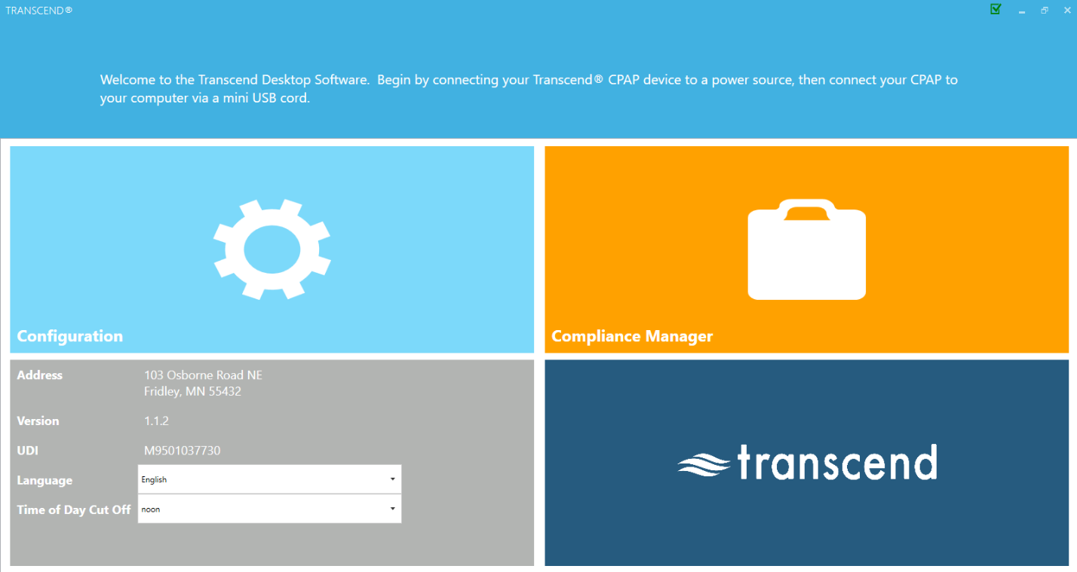
Choose language here
Choose time of day cut off here
Now You’re Ready to Use the Transcend Desktop Software
On the Home screen interface, there are two primary areas to choose from: Configuration or Compliance Manager. Let’s explore each one.
NOTE: If you disconnect your CPAP from a power source while in the software program, the software may return to the home screen until power is resupplied. Any unsaved settings will be lost.

Configuration
Select the Configuration box to open the configuration settings application.
Notice that when you are on any screen, in the right upper corner you will see icons for the available applications in the software. Simply click on any of them and you will go directly to that section.

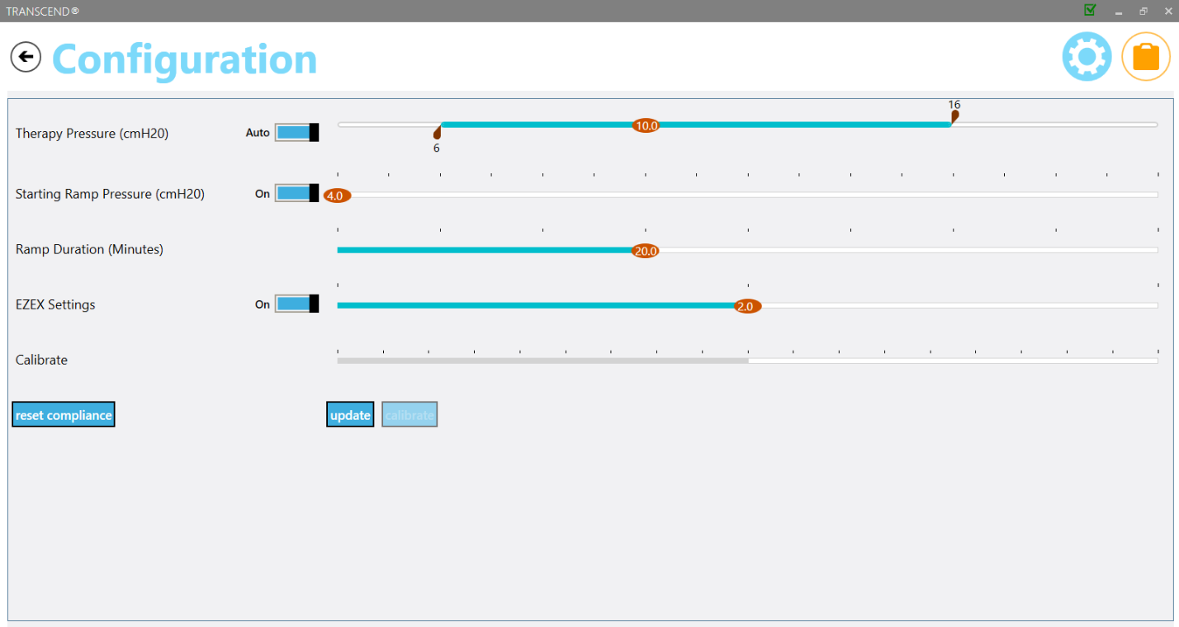

The Configuration area is used to adjust various settings on the device.
Some features, such as the Therapy Pressure and Calibration are clinician settings and are only available with a password.
You can, however, adjust the Ramp Starting Pressure, Ramp Duration and EZEX pressure relief settings if these options have been set by your clinician to be adjustable.
To change them, simply slide on the red oval across the line to the right or left.
- Therapy Pressure is a clinician setting that can only be accessed with a password.
- Ramp Starting Pressure controls the pressure at which your CPAP therapy starts when you engage the Ramp feature. This selection can be adjusted up to 1cmH20 below your Therapy Pressure.
- Ramp Duration controls how long it takes for your CPAP to reach your prescribed therapy pressure when the Ramp feature is engaged. The Ramp feature provides you with a lower therapy pressure to help you fall asleep more comfortably as it slowly Ramps the CPAP pressure up to your prescribed therapy level. This setting can be adjusted between 5 and 45 minutes or toggle the switch to OFF to deactivate this feature.
- EZEX Setting drops the pressure as you breathe out to make exhalation while using your CPAP more comfortable for you. This can be set to OFF, or pressure relief settings between 1 and 3 (3 being the greatest amount of pressure relief).
- Calibrate feature is a clinician setting that can only be accessed with a password. To calibrate the device, first make the appropriate adjustments to the other CPAP settings and click the update button. You will not be able to calibrate the device while you are adjusting the other CPAP settings until you click update. Connect the mask tubing and a manometer to the CPAP and power on the machine. If calibration is needed, select the calibrate button and slide the setting to the appropriate level. Click the calibrate complete button when finished.
- NOTE: To SAVE your adjustments to your CPAP settings, click the update button (next to the calibrate button on your screen) before navigating to another screen.

Compliance Manager
Because both you and your clinician have an interest in the quality of your sessions, the Compliance Manager generates summary data and reports so you can review your sessions by day, week, month or longer.
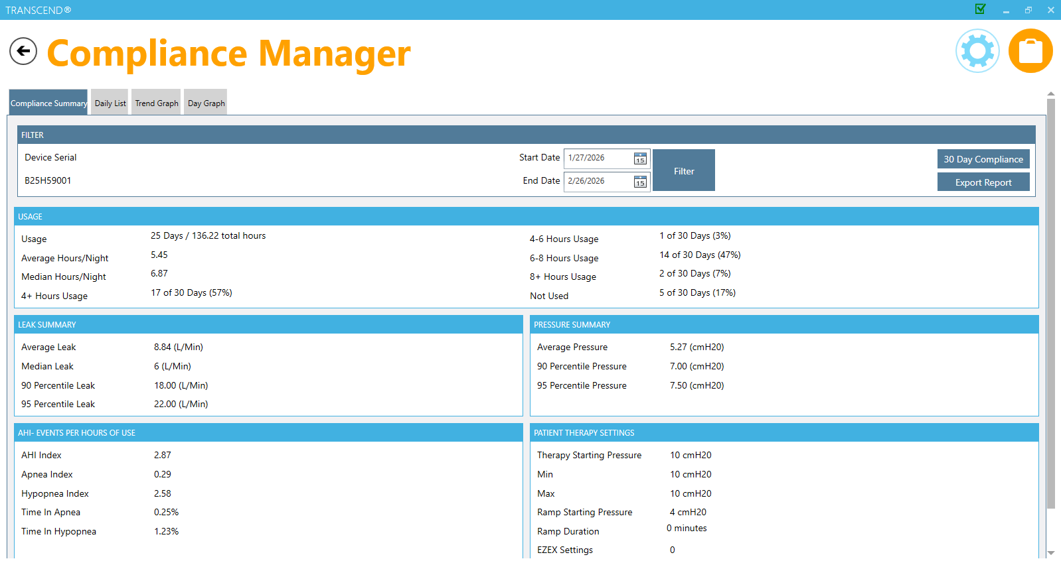
You can see the primary data summaries are:
- Usage
- Leak Summary
- Pressure Summary
- AHI-Events per Hours of Use
- Patient Therapy Settings
The AHI-Events per Hours of Use data summary includes:
Apnea Index – number of Apnea events
Hypopnea Index – number of Hypopnea events
AHI Index – (# of Apnea Events + # of Hypopnea events)/therapy time in hours
These values are estimates provided by sleep apnea breathing therapy equipment and not diagnostic parameters.

General Functions
Filtering by Date
Tailor the date range of information by clicking on the calendar icons next to choose the desired start and end dates.
Then click the Filter button to update the start and end dates you would like to view.
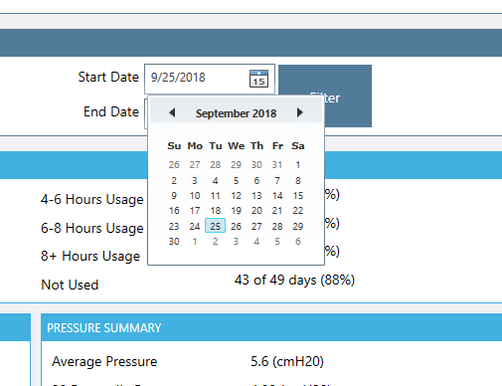
Generate Compliance (Last 30 days of compliance report)
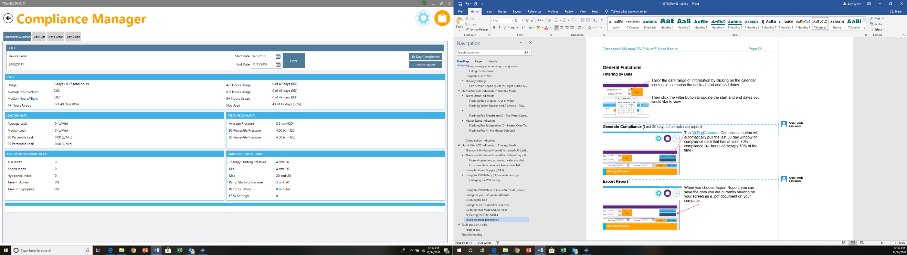
The 30-Day Compliance button will automatically pull the last 30-day window of compliance data that has at least 70% compliance (4+ hours of therapy 70% of the time).
Export Report
When you choose Export Report, you can save the data you are currently viewing on your screen as a .pdf document on your computer.
You will see the following screen after choosing Export Report. Type in the info you wish to save with your report: your name, address, provider name, provider phone and select a location for the .pdf to be stored on your computer. Desktop is recommended as an export location since the file will be easy to locate. Click export report button to save your report as a pdf. Once it’s saved, you can click on the .pdf document to view or print it from your computer.
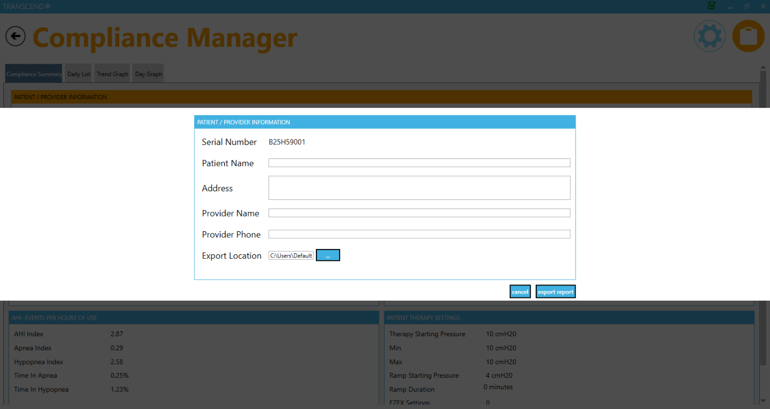
At the top of the page you will also see three grey tabs: Daily List, Trend Graph and Day Graph.
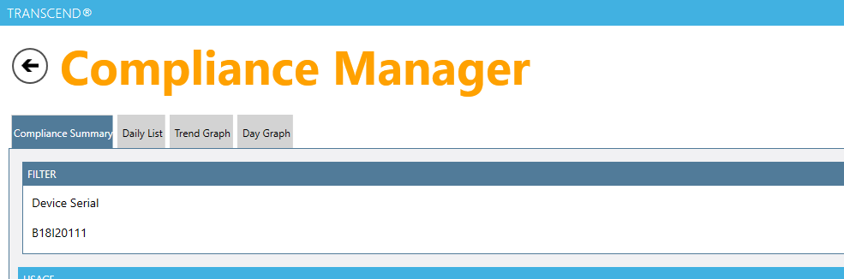

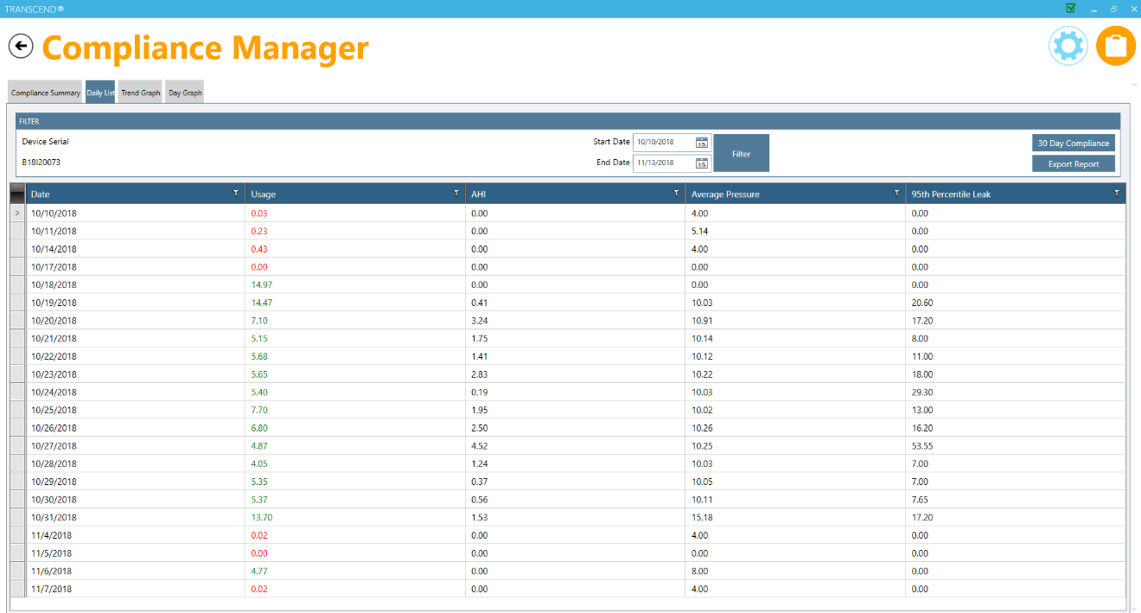
Daily List
When you select the Daily List tab you will see a general summary for the date range you have indicated. Daily List shows the Date, Hours Used, Average AHI (Apnea Hypopnea Index), Average Pressure and Average Leak percentile for each therapy session. You can reverse the order of the data shown by selecting the column header you (Date, Usage, AHI, Average Pressure or 95th Percentile Leak).

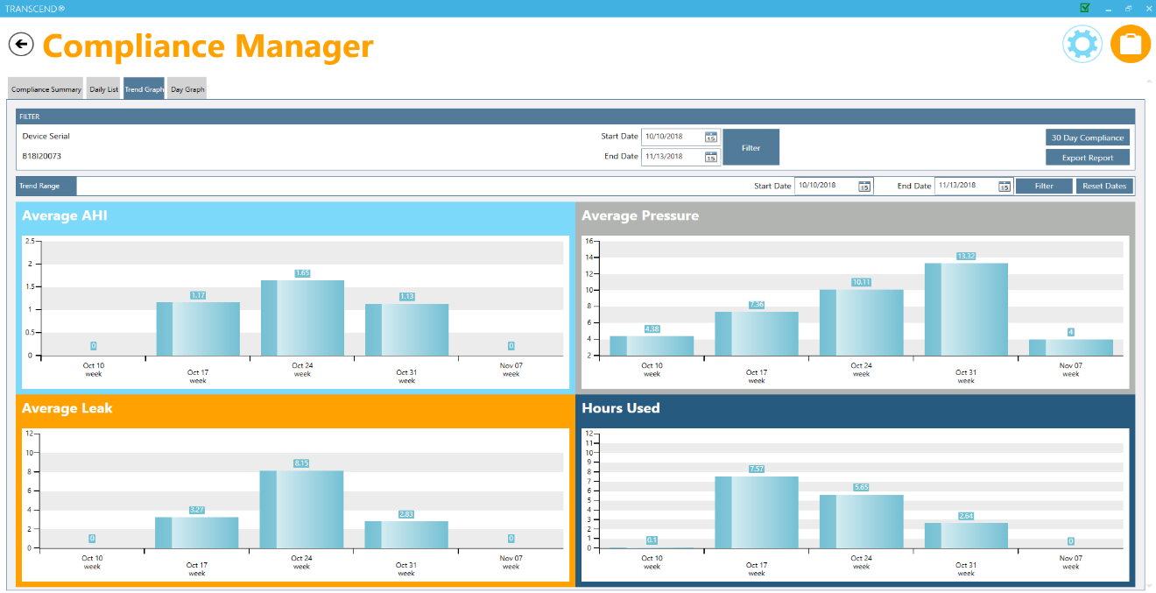
Trend Graph
When you click the Trend Graph tab at the top of the page, you’ll see the data in graphic form. Click on any bar graph and you will see trend ranges by month, week or day each time you click (this change in date range is reflected in the Trend Range section).
At any time, you can adjust the date range you want to view by changing the date range and clicking the Filter button. You can reset the date range after you’ve finished drilling down by hitting the Reset Dates button.

Day Graph
Select the Day Graph tab is used to show data that has been drilled down to the day in the Trend Graph tab or you can go to this tab to select a particular day’s data. You can choose the day you would like to view by selecting the date in the Selected Date field.
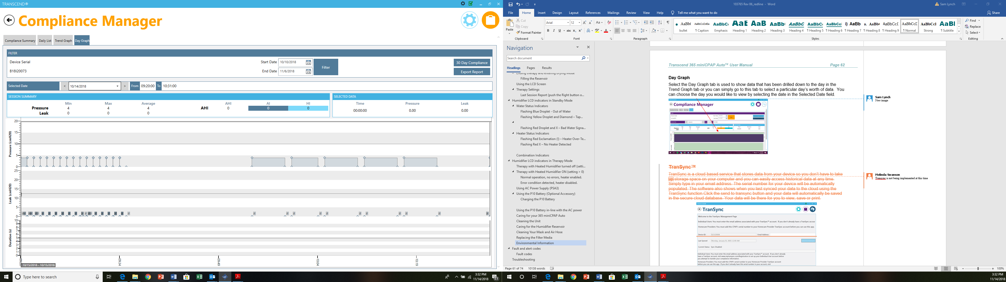

Contact Transcend Inc.
Corporate headquarters | Transcend Inc.
Email | customersupport@mytranscend.com
Web | http://www.MyTranscend.com/
Telephone | 651.621.1800
Toll-free telephone | 877.621.9626
Fax | 651.204.0064
 | Transcend Inc.  103 Osborne Road NE  Fridley, Minnesota 55432 USA  104207 Rev C 2026-03

NOTE: For more detailed descriptions, warnings, cautions and troubleshooting procedures refer to the Transcend Micro User Manual that is available for download at www.MyTranscend.com/support or by calling Transcend customer service at 877-621-9626 to request a copy.

